**My Portfolio**

**By Matthew Jones**

One of the skills which I feel is maybe my best is the communication side to work. This is because I have had a skill since I was young to be able to communicate my views to a group of people furthermore, to also listen to them when they are trying to get their point across. I have used this fairly often as it means that when my group are trying to work together everyone knows what each other are doing and no one feels as if they were not listened to. This makes for a better piece of the work in the end.

Another academic skill that I have learnt at my time at the university is how to structure and write literature reviews. This is because I have had to learn different forms of review and essay styles in CC1023. This is helping increase my writing skills which I would say is a weaker point of my work. This is because I haven’t had much experience writing in these styles. Down below is an extract from a literature review.

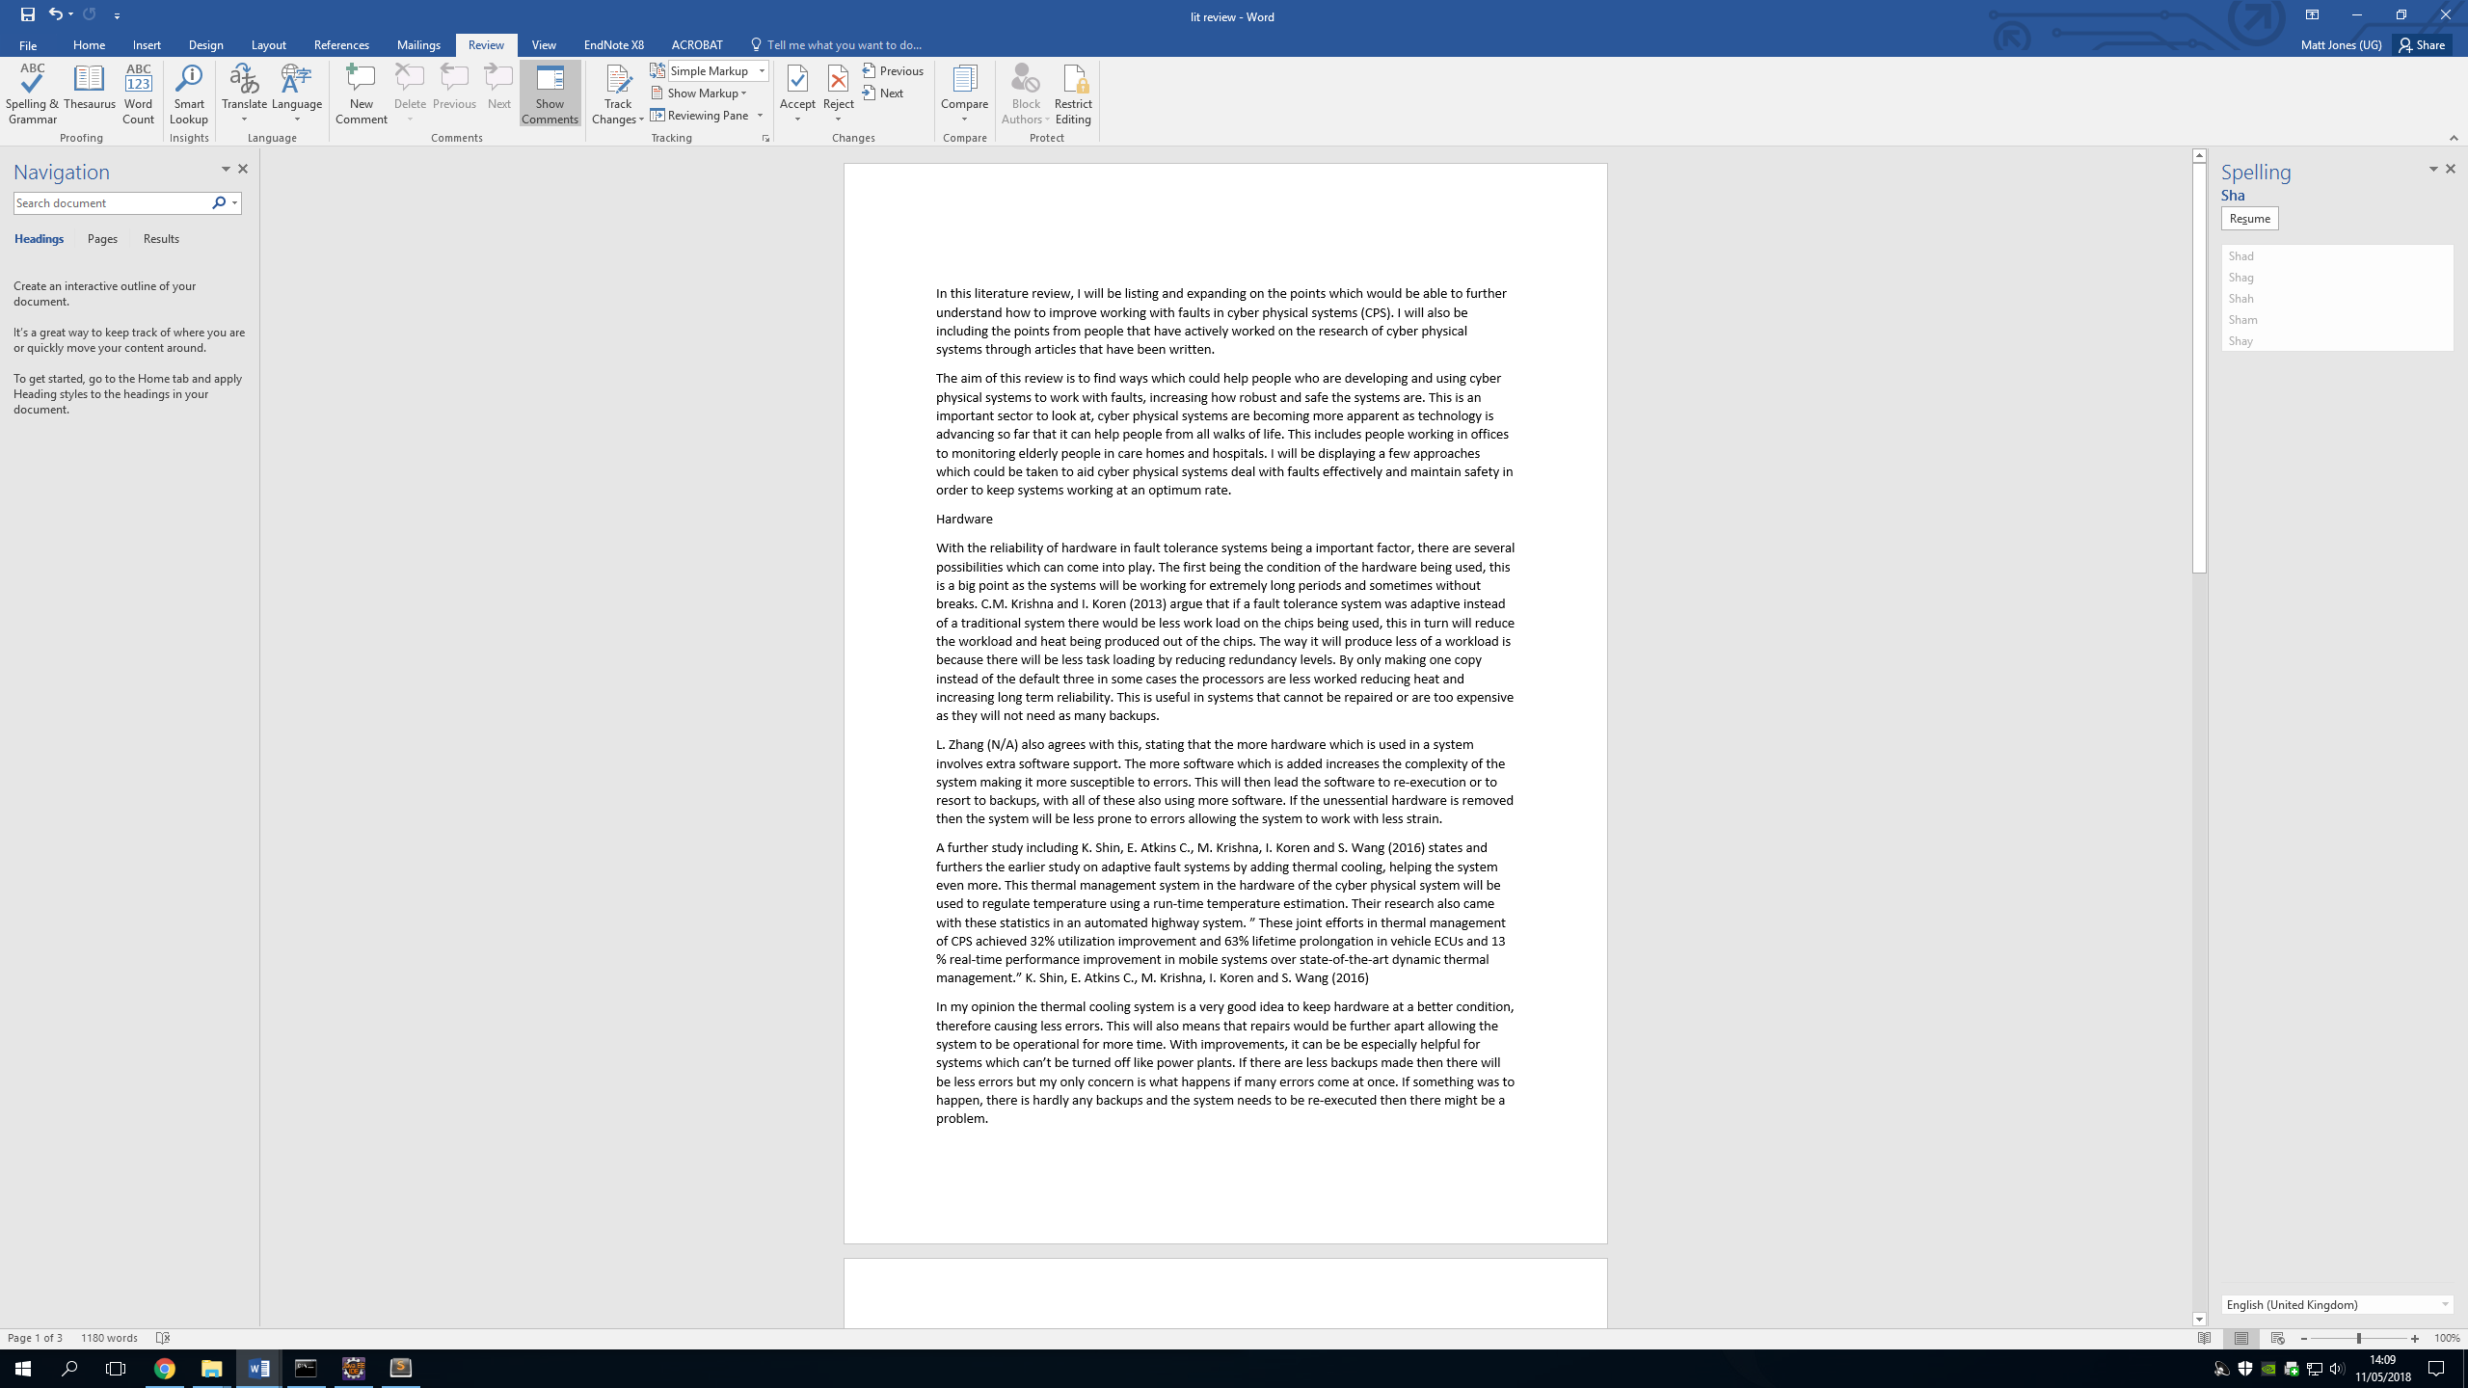

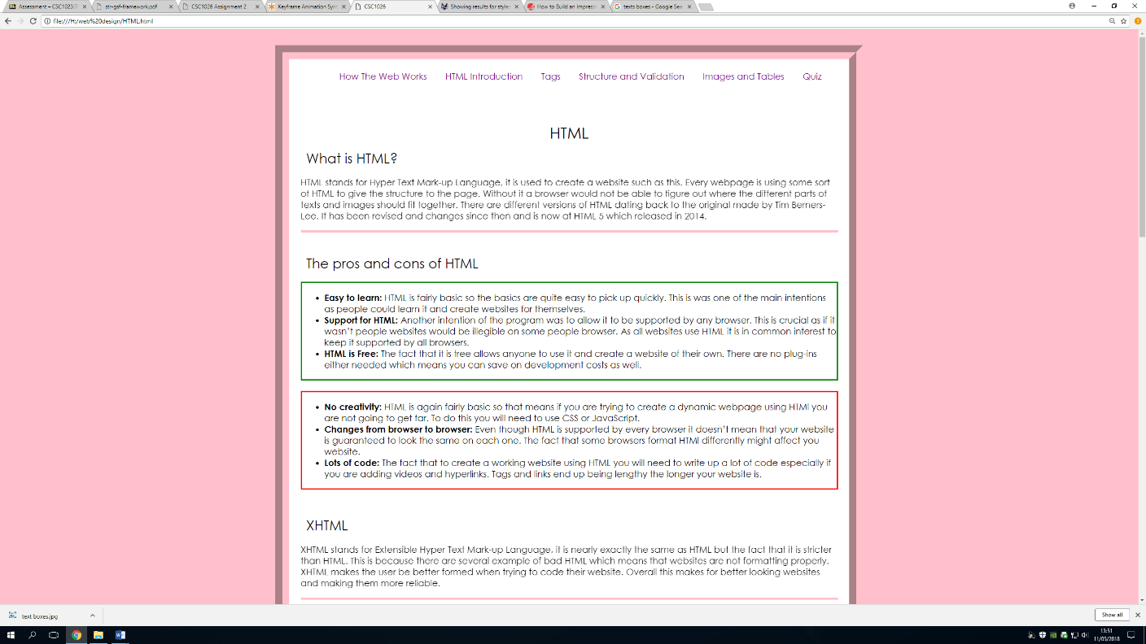

Relating up to the top as well I feel as if I have learnt some basic skills in web design. At the time of writing I have just completed my website for the CSC1026 particle and I can more than say I home happy with how it turned out. I have used in here examples of HTML, CSS and JavaScript which again is utilising everything that I have learnt so far in my tie at Newcastle University. I defiantly enjoy doing this kind of work because it lets me express a more creative side to myself which is not possible in Java or architecture. Here to the left is a picture of the website I have made, I feel as if this could be a direction I take in the future when I start my career.

I have also learned legal awareness, and this is because when I am doing work I need to abide by set of rules which forbids me from using something which is not mine. This has a great skill to have at the start of my career as it will prevent me from making a mistake with it later on in my life. Copyright is also illegal so the further I stay away from these legal issues the better.

I feel as If I have a good skills in basic coding and academic knowledge. This I because I have completed and had working to a good standards several exercise tasks and three projects which were all testing different aspects of the basics in Java. I can know competently even start to try things which I maybe haven’t learned yet in lectures as I feel as if my confidence coding has drastically improved. With my academic knowledge I feel as if I can take in more information than I did at the start. This is maybe because I have a better understanding about what they are talking about a background knowledge. Here is an example down below you can see parts of my code. I am not just stopping here though as I would like to start trying more independent projects that I have set myself and not just coursework.

Critical thinking has been a big part of my work since I started. This is because the work which is being given to me doesn’t just have one way for completion. At first I didn’t think this but as my critical thinking has improved I can now see and actively try different methods to see which has the most positives. This has allowed me to complete assignments closer to the specification which shows that I can follow a client’s main points when I am making a product. Down below shows a picture of the code to my first webpage.

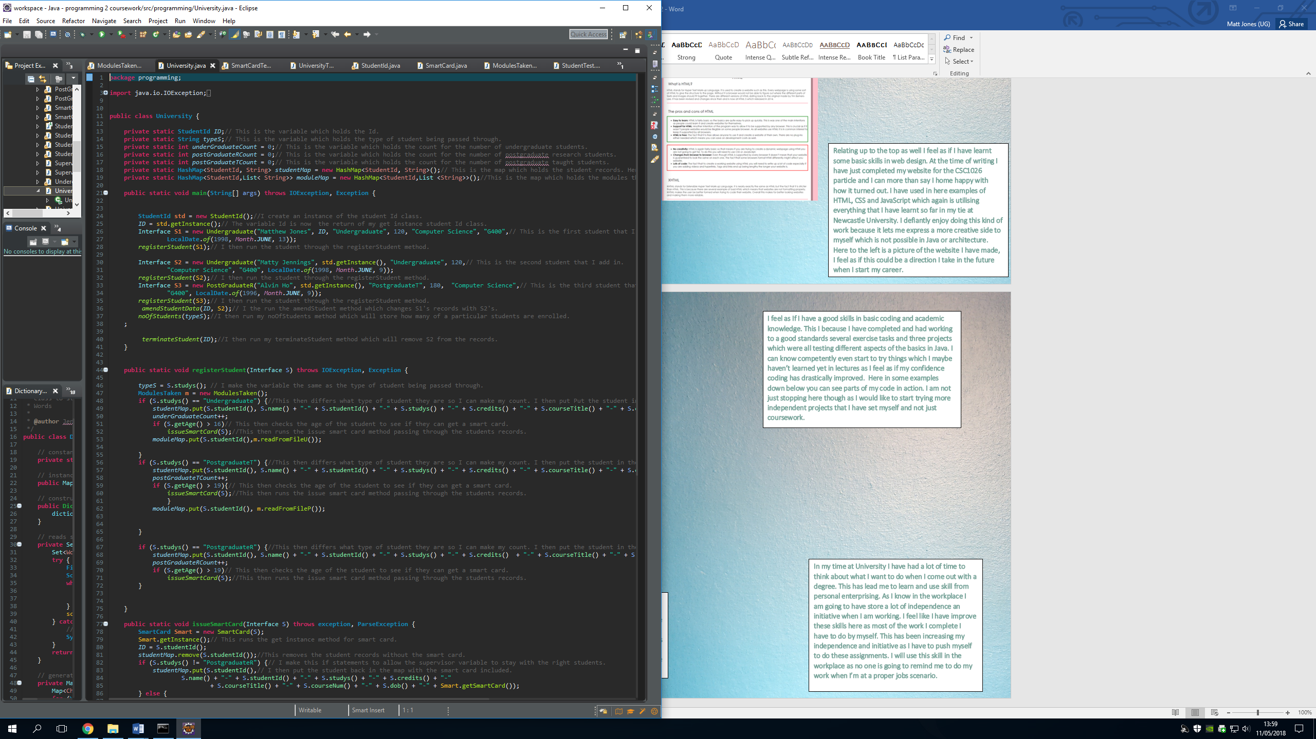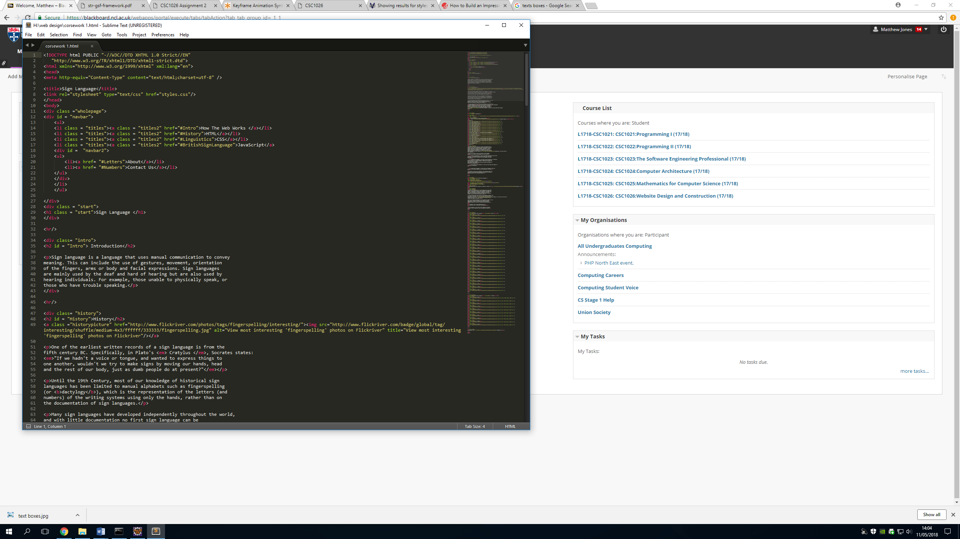

In my time at University I have had a lot of time to think about what I want to do when I come out with a degree. This has lead me to learn and use skill from personal enterprising. As I know in the workplace I am going to have store a lot of independence an initiative when I am working. I feel like I have improve these skills here as most of the work I complete I have to do by myself. This has been increasing my independence and initiative as I have to push myself to do these assignments. I will use this skill in the workplace as no one is going to remind me to do my work when I’m at a proper jobs scenario.

A skill which I have only gained recently is the ability to work in a professional manner. This might seem as a given when you are being taught by professionals in the field, but it still has been a steep learning curve for me. However, I feel as if now I am a fair bit better than I was when starting work and the work ethic that I need to give to all of my assignments. This has helped me as the quality of my work is improving.